Exploring Physics Set 6: Magnetic Fields and Forces

1.

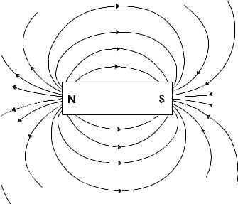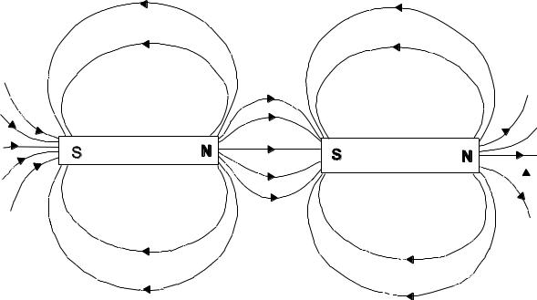

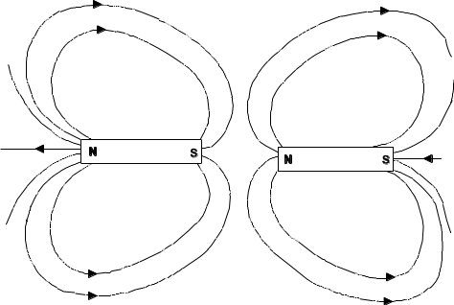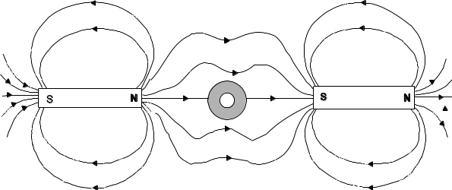

2. A wire carrying a current produces a circular magnetic field around the wire. Iron has a greater permeability for magnetic field than does air. If an iron object is near the wire then the magnetic field will no longer circular around the wire but skewed towards the iron object.

3(a)
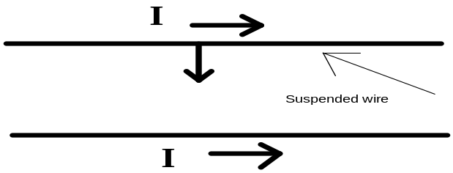

The suspended wire will move towards the fixed conductor.

(b) The suspended wire will move away form the fixed conductor.

4.
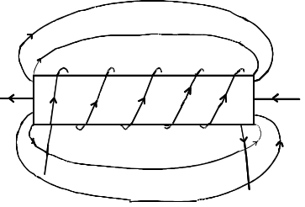

5. = F x d
= 200 x I x l xB x d
= 200 x 0.20 x 0.1 x 0.35 x 1.5 x 10-2
= 2.1 x 10-2 N m

total = 2.1 x 10-2 x 2
= 4.2 x 10-2 N m

6.
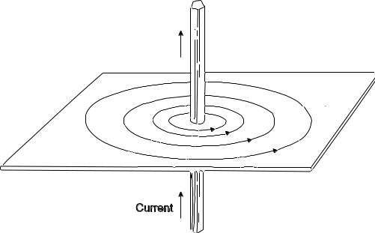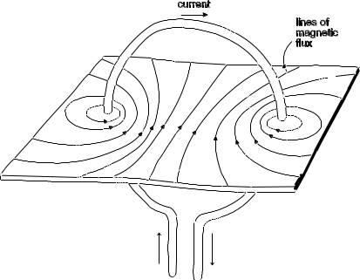

7. The magnetic field produced by the current in the electrical cords can interfere with the magnetic "print" on a video or on a computer disk.

8. (i) Up, towards the top of the page.
(ii) Up, towards the top of the page.
(iii) Up, away from the magnet.
(iv) No force is acting on the conductor.

9. When the current is switched on the magnetic field produced by the solenoid causes the iron rod to move quickly into and partly out the end of the solenoid - and therefore striking the cell.

The bell can be made to ring louder by using a
(i) larger current
(ii) solenoid with more coils

10. F = I l B
= 10 x 0.12 x 20
= 2.4 N

11. Maximum torque on a winding occurs when a current flows through the coil as the winding is in the correct orientation with the magnetic field. With only one winding, this torque is achieved every half revolution. With many windings the maximum torque is achieved more frequently during each revolution. This produces a more steadier torque.

12. F = I l B
= 40 x 75 x 2.5 x 10-5
= 7.5 x 10-2 N, down

13(a) Out of the page
(b) Out of the page
(c) Into the page
(d) Reverse the direction of the current between A and B

14
